Docker & Kubernetes Homework

1. **Project Layout**

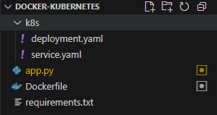

App is a simple Flask web app and prints Hello, World.

1. **Building the image**

Ran into multiple issues for some reason and resorted to using nerdctl and taking the image with localhost/ .

nerdctl build -t localhost/flask-hello:latest .

1. **Running the container**

Running the container is done with

nerdctl run --rm -p 5000:5000 --name hello-test localhost/flask-hello:latest

1. **Kubernetes**

The Kubernetes manifests are deployment.yaml and service.yaml

1. **Deployment**

Deployment is done as such:

kubectl create ns demo 2>$null

kubectl -n demo apply -f k8s/

Watching the pod is done as such:

kubectl -n demo get pods -l app=flask-hello -w

1. **Accessing the app**

By forwarding the port:

kubectl -n demo port-forward svc/flask-hello-service 8080:5000 (available at http://localhost:8080)

or simply http://localhost:3007